INSTALL TENSORFLOW/PYTORCH WITH GPU ON WIN10

In stalling CUDA is totally independent of python. The only thing we need to care for python is which version of Pytorch/Tensorflow you are going to use, which support different version of python

1. Install the Visual Studio community version with C++ for desktop development (we need C++ env before install CUDA) (You can omit this step, I tried, no errors…)
2. Go to the tensorflow release page to check which version of tf you want to use and check carefully which CUDA version it supports <https://github.com/tensorflow/tensorflow/releases>
3. Install Python of supported version by tensorflow (tick the box to add python in the env when installing)
4. Go to CUDA Toolkit download page, download the corresponding version of CUDA toolkit and install <https://developer.nvidia.com/cuda-toolkit-archive>
5. Download cuDNN for corresponding CUDA version, and extract to a folder

<https://developer.nvidia.com/cudnn>

1. Then add three folder path to Path environment variable (for how to add environment variable see <https://superuser.com/questions/949560/how-do-i-set-system-environment-variables-in-windows-10> : click the environment variable and in the “System variables” find “Path”, then double click, then click “new”, finally paste the folder path; you need to create 3 new paths for these 3 things: CUDA, CUPTI, cuDNN)

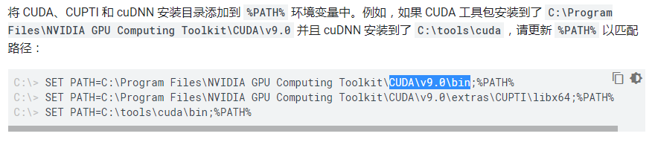

1. Reboot, for path env activate
2. Using pip to install TF with GPU support version (or install pytorch with supported version from the link <https://pytorch.org/get-started/locally/> )
3. Reboot, to make sure
4. Test TF using print + following function in the screen shot;

test pytorch with cuda: print(torch.cuda.is_available())

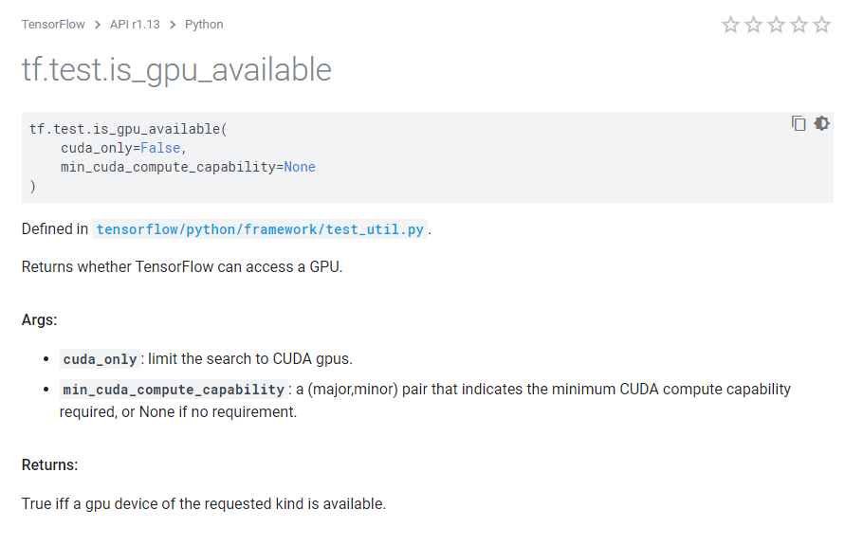

INSTALL rllab

1. Go to the repo download whole file

<https://github.com/rll/rllab>

1. Install the rllab as a package using:

python setup.py install

1. Install swig for windows

<http://www.swig.org/download.html>

add swig.exe folder to path

and reboot

1. This repo is just shit!

INSTALL PYTORCH WITH GPU ON UBUNTU 18.04

The only difficulty is installing Ubuntu 18.04 (alongside/not alongside with win10). Here is how to install it

1. Create a ubuntu installing booting usb device
2. Plug in usb, enter in BIOS, turn off secure boot: under secure tab, there is a “secure boot” option, go into it, and turn off secure boot mode. No need to change UEFI mode
3. Change boot priority to usb device
4. Reboot and now you should be able to load Grub menu
5. Highlight the “INSTALL UBUNTU” option, and press “e”;
6. Find the line that starts with *linux* then add *modprobe.blacklist=nouveau* after *quiet splash*.
7. Press Ctrl + x to launch installing (or you can just reboot)
8. Normally install Ubuntu
9. It will tell you to reboot, do it, and press “F11” all the time just like pressing “delete” when entering BIOS. (this step is to manually call Grub menu for multi system switching)
10. Follow the instructions on screen
11. Similarly, Highlight the “UBUNTU” option, and press “e”;

Find the line that starts with *linux* then add *modprobe.blacklist=nouveau* after *quiet splash*.

1. Press Ctrl + x to launch linux (or you can just reboot)
2. Now you have installed Ubuntu
3. The reason why we disable security boot is that it will cause third party package installation error.
4. Wait the system auto update and update it, as it contains newest files that shipped with the update, which will be used.
5. The reason why we add modprobe blacklist code is to disable the Ubuntu system using nouveau driver which is a driver for Nvidia designed by third party so that to disable nvidia d card, as using this driver and GPU will prevent you from installing system. You will not boot to installation/system! Whenever the nvidia driver is not ready, you should use this command to kill nvidia card. After you install nvidia driver, you can normally boot to system.

So the logic is this: disable nvidia card to install system -> install nvidia driver after installing the system -> use nvidia card.

INSTALL NVIDIA GPU DRIVER

1. Go to this website: <https://launchpad.net/~graphics-drivers/+archive/ubuntu/ppa>

This site is Ubuntu official website where they provide Nvidia driver distribution which is modified for easy installation. Don’t use Nvidia original driver installation from its official site, cause it will be too messy and cause potential problems. Thank you Ubuntu, love you!

1. Go to the bottom of the and run the two lines of command to add this driver repo to apt manager so that you can install the driver.

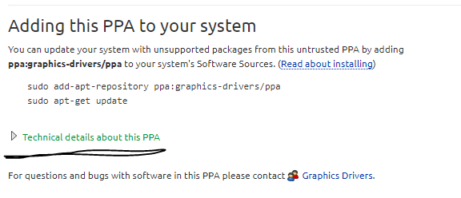

1. Then go to Ubuntu, and search for the app “software & update”. In this app, click the “additional driver” tab, then you can find nvidia driver with different version supported by ppa Ubuntu.
2. Install from one of them
3. Reboot
4. Now you are done with driver installation

INSTALL CUDA & cuDNN (for tf)

1. CUDA installation is easy, just go to Nvidia cuda website and download cuda-toolkit for “deb” version and follow the instructions on the download webpage
2. cuDNN is also easy. Just follow the instructions on cuDNN webpage, remember to use gtz zipped file installation.
3. Add path environment variables:

You can directly run bash shell I wrote from google drive, file name “addEnvvar.sh”

Add the following lines to your ~/.profile file for CUDA 10.0

# set PATH for cuda 10.0 installation

if [ -d "/usr/local/cuda-10.0/bin/" ]; then

export PATH=/usr/local/cuda-10.0/bin${PATH:+:${PATH}}

export LD_LIBRARY_PATH=/usr/local/cuda-10.0/lib64${LD_LIBRARY_PATH:+:${LD_LIBRARY_PATH}}

fi

<https://askubuntu.com/questions/1077061/how-do-i-install-nvidia-and-cuda-drivers-into-ubuntu>

also remember to add CUPTA to path:

export LD_LIBRARY_PATH=$LD_LIBRARY_PATH:/usr/local/cuda/extras/CUPTI/lib64

<https://www.tensorflow.org/install/gpu>

You are good to go!